Deadlock Avoidance
# Source: AI Source: Provided by: [Data Path: Persons Table -> ID Column: 1, Name_En Column: Motasem Essam] -> From: [ChatGPT] on [1/21/2026]
Deadlock Avoidance is a technique used in Real-Time Systems (RTS) to ensure that tasks never enter a state where they are permanently waiting for resources, which could halt the system.

Definition
# Source: AI Source: Provided by: [Data Path: Persons Table -> ID Column: 1, Name_En Column: Motasem Essam] -> From: [ChatGPT] on [1/21/2026]
Deadlock avoidance is a proactive resource management technique in which the system analyzes resource requests before granting them to ensure that granting a request will not lead to a deadlock.
- The system only allocates resources if it can guarantee that all tasks can eventually complete.
- Unlike deadlock detection (which resolves deadlocks after they occur), deadlock avoidance prevents deadlocks from happening.

Key Concepts
# Source: AI Source: Provided by: [Data Path: Persons Table -> ID Column: 1, Name_En Column: Motasem Essam] -> From: [ChatGPT] on [1/21/2026]
- Safe State
  - A system is in a safe state if there exists a sequence of task execution such that all tasks can finish without deadlocks.
- Unsafe State
  - Allocating a resource may lead to a state where no safe sequence exists, risking a deadlock.
- Resource Request Checking
  - Before granting a resource, the system checks if the allocation keeps the system in a safe state.

Common Deadlock Avoidance Algorithms
# Source: AI Source: Provided by: [Data Path: Persons Table -> ID Column: 1, Name_En Column: Motasem Essam] -> From: [ChatGPT] on [1/21/2026]
- Banker’s Algorithm (Dijkstra’s Algorithm)
  - Each task declares its maximum resource requirement in advance.
  - The system grants requests only if it can remain in a safe state.
- Resource Allocation Graph (RAG) Algorithm
  - Graph-based method to detect potential cycles before they occur, preventing deadlocks.

Example
# Source: AI Source: Provided by: [Data Path: Persons Table -> ID Column: 1, Name_En Column: Motasem Essam] -> From: [ChatGPT] on [1/21/2026]
Suppose we have 3 resources (R1, R2, R3) and 2 tasks (T1, T2):
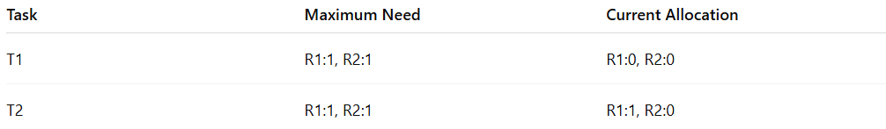
Task | Maximum Need | Current Allocation
T1 | R1:1, R2:1 | R1:0, R2:0
T2 | R1:1, R2:1 | R1:1, R2:0
- T1 requests R2
- System checks: granting R2 keeps system in safe state → approve
- T2 requests R2
- Granting R2 would lead to no safe sequence → deny request
This ensures tasks never enter deadlock.

Advantages
# Source: AI Source: Provided by: [Data Path: Persons Table -> ID Column: 1, Name_En Column: Motasem Essam] -> From: [ChatGPT] on [1/21/2026]
- Prevents deadlocks completely.
- Ensures system stability and reliability.
- Suitable for hard real-time systems where deadlocks are unacceptable.

Disadvantages
# Source: AI Source: Provided by: [Data Path: Persons Table -> ID Column: 1, Name_En Column: Motasem Essam] -> From: [ChatGPT] on [1/21/2026]
- Requires prior knowledge of maximum resource needs (may be difficult in dynamic systems).
- Complex to implement for systems with many tasks and resources.
- Computational overhead in checking safe states.

Why Deadlock Avoidance Matters for Software Engineers
# Source: AI Source: Provided by: [Data Path: Persons Table -> ID Column: 1, Name_En Column: Motasem Essam] -> From: [ChatGPT] on [1/21/2026]
- Critical for real-time embedded systems, robotics, and industrial automation.
- Ensures that all tasks can meet their deadlines without getting stuck.
- Helps in designing robust resource management strategies in RTOS.

